**LAB MANUAL**

Of Subject

**ESSENTIAL SKILLS OF INFORMATION TECHNOLOGY**

**Subject Codes: 09CT0101**

**Student Name:** RAHUL SHARMA

**Enrollment No:** 91900957026

**Submission Date:12/11/2019**

**Department of Information & Communication Technology**

**Student of Diploma Engineering**

**ESIT LAB**

**PRACTICAL INDEX**

|  |  |  |  |  |
| --- | --- | --- | --- | --- |
| **SR.NO.** | **TITLE** |  |  |  |
| **1** | **HTML WEBSITE** |  |  |  |
| **2** | **CSS** |  |  |  |
| **3** | **DOCUMENTATION** |  |  |  |
| **4** | **JAVASCRIPT** |  |  |  |
| **5** | **INTRODUCTION**  **TO COMPUTER** |  |  |  |
| **6** | **SOLOLEARN HTML CERTIFICATE** |  |  |  |
| **7** | **SOLOLEARN CSS CERTIFICATE** |  |  |  |
| **8** | **SOLOLEARN JAVASCRIPT CERTIFICATE** |  |  |  |

**STUDENT NAME: RAHUL SHARMA**

**STUDENT SIGN:**

**FACULTY SIGN HOD**

**SIGN**

**PRACTICAL 1: HTML WEBSITE**

**Problem statement: Make a static website made in HTML.**

**Solution:**

**File Name : MainFrame.html**

**code:**

**<html>**

**<frameset rows="25%,75%">**

**<frame src="Header.html"/>**

**<frameset cols="25%,75%">**

**<frame src="Navigation.html"/>**

**<frame src="" name="showframe"/>**

**</frameset>**

**</frameset>**

**</html>**

**OUTPUT:**

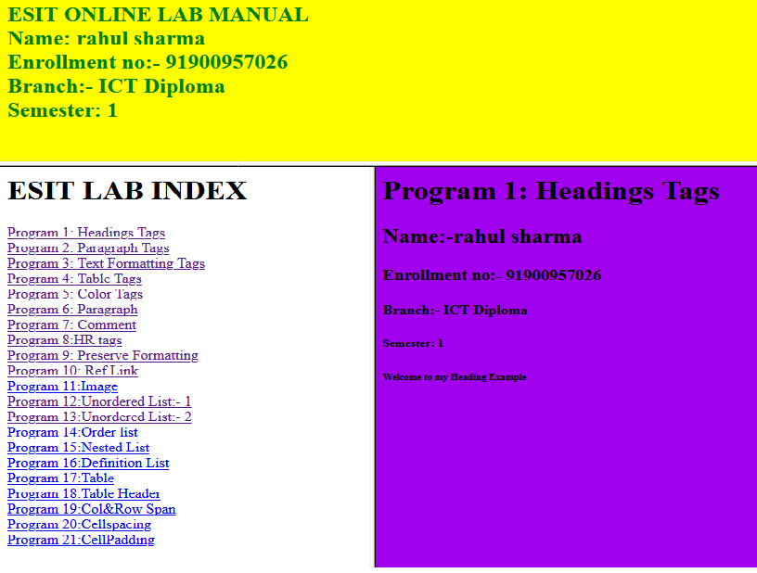

**File Name :NAVIGATION.HTML**

**CODE:**

<html>

<body>

<h1> ESIT LAB INDEX</h1>

<a href="1.html" target="showframe"/>Program 1: Headings Tags</a>

<br/>

<a href="2.html" target="showframe"/>Program 2: Paragraph Tags</a>

<br/>

<a href="3.html" target="showframe"/>Program 3: Text Formatting Tags</a>

<br/>

<a href="4.html" target="showframe"/>Program 4: Table Tags</a>

<br/>

<a href="5.html" target="showframe"/>Program 5: frist html file</a>

<br/>

<a href="6.html" target="showframe"/>Program 6: heading Tags</a>

<br/>

<a href="7.html" target="showframe"/>Program 7: color text Tags</a>

<br/>

<a href="8.html" target="showframe"/>Program 8: paragraph Tags</a>

<br/>

<a href="9.html" target="showframe"/>Program 9: hr and paragraph Tags</a>

<br/>

<a href="10.html" target="showframe"/>Program 10: ordered list</a>

<br/>

<a href="11.html" target="showframe"/>Program 11: unordered list</a>

<br/>

<a href="12.html" target="showframe"/>Program 12: nested list</a>

<br/>

<a href="13.html" target="showframe"/>Program 13: definition list</a>

<br/>

<a href="14.html" target="showframe"/>Program 14: table</a>

<br/>

</body>

</html>

OUTPUT:

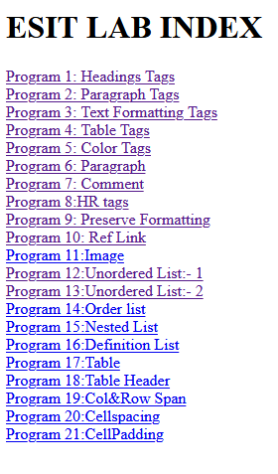

**File Name :HEADER.HTML**

**CODE:**

**<html>**

**<body bgcolor="cyan" style="color:Brown">**

**<h2>ESIT ASSIGNMENT <br/>**

**Name: Rahul sharma<br/>**

**STUDY :ICT-Diploma Engineering <br/>**

**date of making assignment :8 sep 2019 </br>**

**Semester: 1 Class: DK1 </h2>**

**</body>**

**</html>**

OUTPUT:

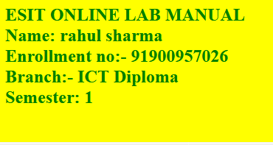

**File Name :HEADING.HTML**

**CODE:**

**<html>**

**<body bgcolor="blue">**

**<h1>Program 1: Headings Tags</h1>**

**<h2>Name: Rahul sharma</h2>**

**<h3>Department: ICT</h3>**

**<h4>Stream: DIPLOMA</h4>**

**<h5>Semester: 1</h5>**

**<h6>roll no :91900957026</h6>**

**<h7>Welcome to my html programe</h7>**

**</body>**

**</html>**

OUTPUT: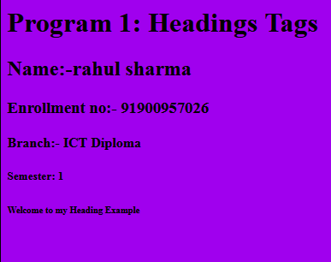

**File Name :TABLE TAG.HTML**

**CODE:**

**<html>**

**<body bgcolor="gray">**

**<h1>Program 4: Table Tags</h1>**

**<table border="3">**

**<tr>**

**<th>Enrollment No</th>**

**<th>Name</th>**

**<th>Semester</th>**

**<th>Department</th>**

**<th>Course</th>**

**</tr>**

**<tr>**

**<td>91900957026</td>**

**<td>rahul sharma</td>**

**<td>1</td>**

**<td>ICT</td>**

**<td>Diploma</td>**

**</tr>**

**</table>**

**</body>**

**</html>**

**OUTPUT:**

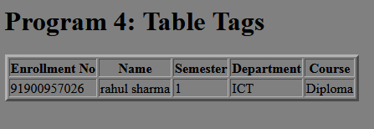

File Name :CSS BORDERS

<html>

<head>

<style>

p.dotted {background:pink; border-style:dotted; border-style: dotted; border-width: thick;border-color:blue;}

p.dashed {background:yellow;border-style: dashed; border-style:dashed; border-width:15px ;border-color:red;}

p.solid {background:aqua;border-style: solid; border-style: solid;

border-width: medium;border-color:green;}

p.double {background:burlywood;border-style: double; border-style: double;

border-width: 10px;border-color:yellow;}

p.groove {background:crimson;border-style: groove; border-style:groove;

border-width: 15px;border-color:pink;}

p.ridge {background:darksalmon;border-style: ridge; border-style: ridge;

border-width: thick;border-color:blue;}

p.inset {background:firebrick;border-style: inset; border-style: inset;

border-width:thick;border-style: yellow;}

p.outset {background:yellow;border-style: outset; border-style: outset;

border-width: 15px;border-style: brown;}

p.none {background:deepskyblue;border-style: none;border-style: none;

border-width: 5px;border-style:red;}

p.hidden {background:indigo;border-style: hidden;border-style: hidden;

border-width: 5px;border-style:black;}

p.mix {background:orange;border-style: dotted dashed solid double;border-style: dotted dashed solid double;

border-width: 5px;border-color:green orange red blue;}

</style>

</head>

<body>

<h2>The border-style Property</h2>

<p>This property specifies what kind of border to display:</p>

<p class="dotted">Name:Rahul Sharma<br>

Enrollment no:91900957026<br>

Dept:ICT<br>

Class:DK1<br>

Semester:1<br>

Course:ICT Diploma</p>

<p class="dashed">Name:Rahul Sharma<br>

Enrollment no:91900957026<br>

Dept:ICT<br>

Class:DK1<br>

Semester:1<br>

Course:ICT Diploma</p>

<p class="solid">Name:Rahul Sharma<br>

Enrollment no:91900957026<br>

Dept:ICT<br>

Class:DK1<br>

Semester:1<br>

Course:ICT Diploma</p>

<p class="double">Name:Rahul Sharma<br>

Enrollment no:91900957026<br>

Dept:ICT<br>

Class:DK1<br>

Semester:1<br>

Course:ICT Diploma</p>

<p class="groove">Name:Rahul Sharma<br>

Enrollment no:91900957026<br>

Dept:ICT<br>

Class:DK1<br>

Semester:1<br>

Course:ICT Diploma</p>

<p class="ridge">Name:Rahul Sharma<br>

Enrollment no:91900957026<br>

Dept:ICT<br>

Class:DK1<br>

Semester:1<br>

Course:ICT Diploma</p>

<p class="inset">Name:Rahul Sharma<br>

Enrollment no:91900957026<br>

Dept:ICT<br>

Class:DK1<br>

Semester:1<br>

Course:ICT Diploma</p>

<p class="outset">Name:Rahul Sharma<br>

Enrollment no:91900957026<br>

Dept:ICT<br>

Class:DK1<br>

Semester:1<br>

Course:ICT Diploma</p>

<p class="none">Name:Rahul Sharma<br>

Enrollment no:91900957026<br>

Dept:ICT<br>

Class:DK1<br>

Semester:1<br>

Course:ICT Diploma</p>

<p class="hidden">Name:Rahul Sharma<br>

Enrollment no:91900957026<br>

Dept:ICT<br>

Class:DK1<br>

Semester:1<br>

Course:ICT Diploma</p>

<p class="mix">Name:Rahul Sharma<br>

Enrollment no:91900957026<br>

Dept:ICT<br>

Class:DK1<br>

Semester:1<br>

Course:ICT Diploma</p>

</body>

</html>

OUTPUT:

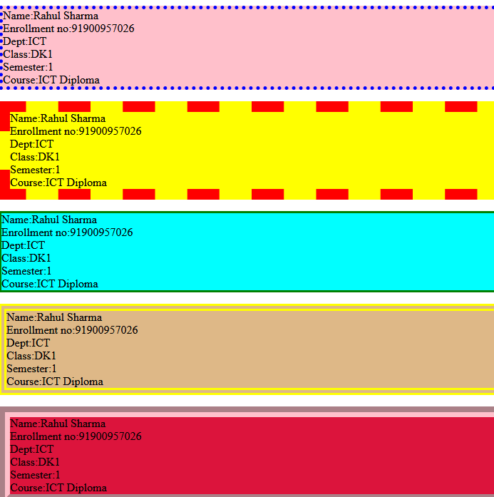

File Name :CSS TEXT

<html>

<head>

<style>

body{

background-color:lightgreen;

}

h1{

color:red;

text-align:center;

text-decoration:underline;

text-shadow:3px 3px white;

text-transform:lowercase;

text-indent:-75px;

word-spacing:-10px;

}

h2{

color:white;

text-align:center;

text-decoration:underline;

text-shadow:3px 3px red;

text-indent:75px;

}

h3{

color:white;

text-align:center;

text-decoration:underline;

text-shadow:3px 3px black;

word-spacing:10px;

}

h4{

color:lightyellow;

text-align:center;

text-decoration:line-through;

}

p{

letter-spacing:5px;

text-align:justify

}

</style>

</head>

<body>

<h1>This is my world</h1>

<h2>About my life</h2>

<p><b>This is my world</b></p>

<p>Hello my name is Rahul sharma and i am studying in the ICT diploma at marwadi university ,Rajkot .I am from Rajasthan,Jaipur.Hello my name is Rahul sharma and i am studying in the ICT diploma at marwadi university ,Rajkot .I am from Rajasthan,Jaipur.Hello my name is Rahul sharma and i am studying in the ICT diploma at marwadi university ,Rajkot .I am from Rajasthan,Jaipur. </p>

<h3>Thanks to read about my life</h3>

<h4>Visit again</h4>

</body>

</html>

OUTPUT:

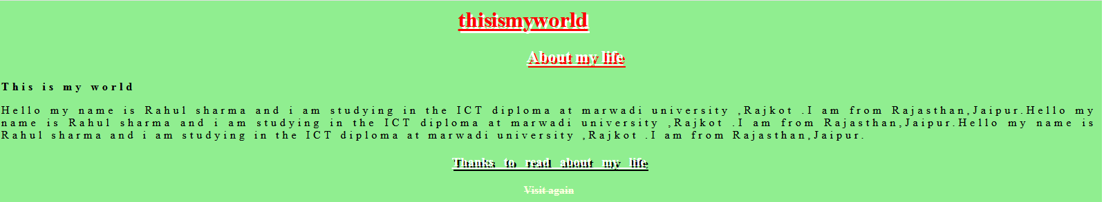

File Name :CSS MULTIPLE COLUMN

<html>

<head>

<style>

.newspaper {

/* Chrome, Safari, Opera */

-webkit-column-count: 5;

-webkit-column-gap: 40px;

-webkit-column-rule-style:dashed ;

/* Firefox */

-moz-column-count: 3;

-moz-column-gap: 50px;

-moz-column-rule-style:solid;

column-count: 3;

column-gap: 40px;

column-rule-style:dashed;

}

h1{

color:dodgeblue;

}

</style>

</head>

<body bgcolor="seagreen">

<h1>The column-rule-style Property</h1>

<p><b>This is my world:</b></p>

<div class="newspaper">

A car (or automobile) is a wheeled motor vehicle used for transportation. Most definitions of car say they run primarily on roads, seat one to eight people, have four tires, and mainly transport people rather than goods.[2][3]

Cars came into global use during the 20th century, and developed economies depend on them.

</div>

<p><strong>Note:</strong> The column-rule-style property is not supported in Internet Explorer 9 and earlier versions.</p>

</body>

</html>

OUTPUT:

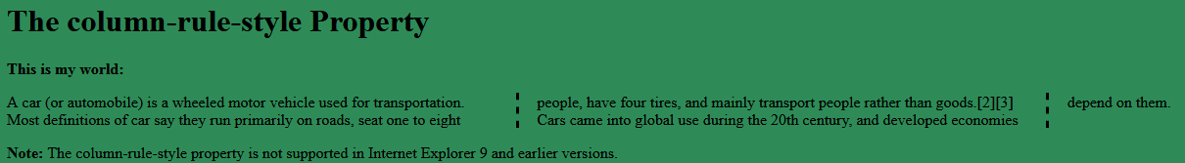

File Name :CSS SELECTOR



<html>

<head>

<style>

*{

text-align: center;

color:blue;

}

body{

background-color:Crimson;

}

#p1 {

text-align: left;

border-style:groove ;

font-size: 25px;

color: cyan;

}

#para1 {

border-style:dotted;

font-size: 25px;

color:red;

}

.center {

text-align: center;

border-style: dashed;

font-size: 30px;

color:seagreen;

}

h1,h2,h3,h4,h5,h6, p {

text-align: right;

text-shadow:3px 2px FloralWhite ;

color: yollow;

}

div p {

border-style: outset;

border-color:yellow;

background-color:DeepSkyBlue ;

}

table, th, td {

border: 10px solid Orange ;

}

<div> p {

background-color:LightSalmon;

}

</style>

<p id="p1">This is CSS selector </p>

<p id="para1">This is CSS selector</p>

<p id="para1">This is CSS selector</p>

<p class=center>This is CSS selector</p>

<table>

<tr>

<th>My name</th>

<th>Age</th>

<th>Roll no.</th>

<th>department</th>

</tr>

<tr>

<td>Rahul Sharma</td>

<td>18</td>

<td>91900957026</td>

<td>ICT Diploma</td>

</tr>

</table>

<h1>This is my world</h1>

<h2>This is my world</h2>

<h3>This is my world</h3>

<h4>This is my world</h4>

<h5>This is my world</h5>

<h6>This is my world</h6>

<p>My name is Rahul Sharma <span style="color:black;font-weight:bold">Rahul</span> <span style="color:darkolivegreen;font-weight:bold">dark green</span> eyes.</p>

<p><b>The shlokas, mantras and excerpts from various Hindu mythology scriptures and texts have been transformed into various themes. Surya Raj Kamal has composed 20 original compositions for Raasleela of Radha-Krishna.</b></p>

<h1>This is about Radha Krishana</h1>

<div>

<p>This is CSS selector </p>

</div>

<p>This is my world</p>

<div>

<p>This is my world</p>

<section><p>This is my world</p></section>

<p>This is my world</p>

</div>

</body>

</html>

OUTPUT:

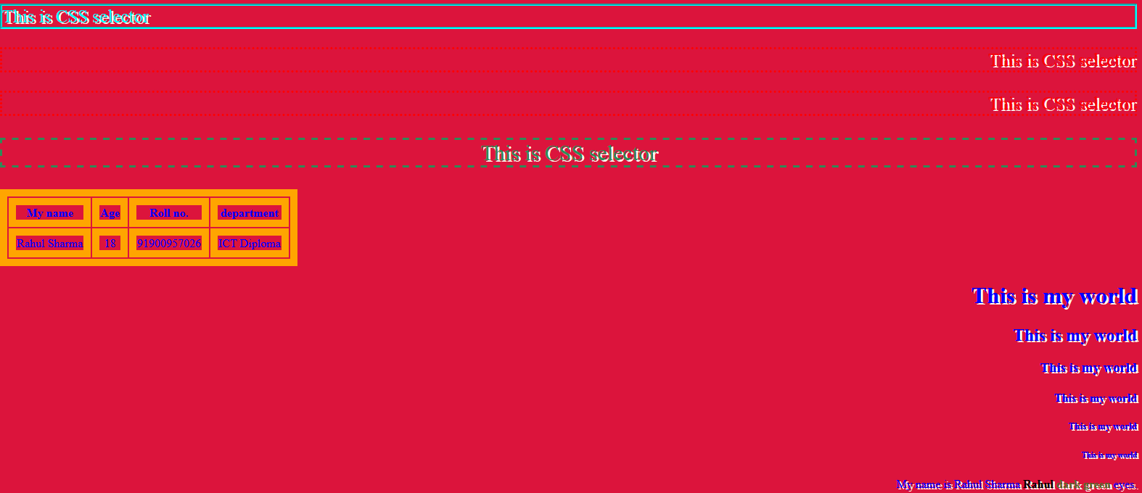

File Name : **JavaScript Variables**

**Code:**

**<html>**

**<body>**

**<h2>JavaScript Variables</h2>**

**<p id="demo"></p>**

**<script>**

**var x = "John" + " " + "Doe";**

**document.getElementById("demo").innerHTML = x;**

**</script>**

**<p>the result of adding 2+3+"5":</p>**

**<p id="demo2"></p>**

**<script>**

**document.getElementById("demo2").innerHTML = x;**

**</script>**

**<p id="demo3"></p>**

**<script>**

**var x=5+5;**

**var y="5"+5;**

**var z="hello"+5;**

**document.getElementById("demo3").innerHTML =**

**x + "<br>" + y +"<br>"+z;**

**</script>**

**</body>**

**</html>**

Output:

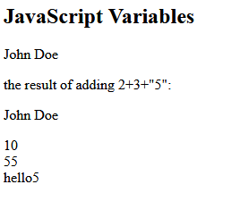

File Name : **JavaScript Variables addition**

<html>

<body>

<h2>Javascript Variables </h2>

Number 1: <input type="text" id="n1" name="n1"/>

<br/> + <br/>

Number 2: <input type="text" id="n2" name="n2"/>

<br/>

<p id="ans"></p>

<input type="button" value="Add" onclick="add()"/>

<script>

var a, b, result;

function add()

{

a = parseInt(document.getElementById("n1").value);

b = parseInt(document.getElementById("n2").value);

result = a+ b;

alert(result);

}

</script>

</body>

</html>

OUTPUT:

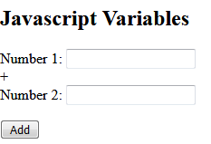

File Name : **JavaScript Variables add ,sub ,div and multi**

**Code:**

**<html>**

**<body>**

**<h2>Javascript Variables </h2>**

**Number 1: <input type="text" id="n1" name="n1"/>**

**<br/> + <br/>**

**Number 2: <input type="text" id="n2" name="n2"/>**

**<br/>**

**<p id="ans"></p>**

**<input type="button" value="Add" onclick="add()"/>**

**<input type="button" value="Sub" onclick="sub()"/>**

**<input type="button" value="Mult" onclick="mult()"/>**

**<input type="button" value="Div" onclick="div()"/>**

**<script>**

**var a, b, result;**

**function add()**

**{**

**a = parseInt(document.getElementById("n1").value);**

**b = parseInt(document.getElementById("n2").value);**

**result = a + b;**

**alert(result);**

**}**

**function sub()**

**{**

**a = parseInt(document.getElementById("n1").value);**

**b = parseInt(document.getElementById("n2").value);**

**result = a - b;**

**alert(result);**

**}**

**function mult()**

**{**

**a = parseInt(document.getElementById("n1").value);**

**b = parseInt(document.getElementById("n2").value);**

**result = a * b;**

**alert(result);**

**}**

**function div()**

**{**

**a = parseInt(document.getElementById("n1").value);**

**b = parseInt(document.getElementById("n2").value);**

**result = a / b;**

**alert(result);**

**}**

**</script>**

**</body>**

**</html>**

OUTPUT:

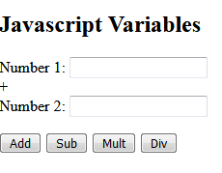

File Name : **JavaScript even no**

code:

<html>

<head>

<script>

function odd_even(){

var no;

no=Number(document.getElementById("no_input").value);

if(no%2==0)

{

alert("Even Number");

}

else

{

alert("Odd Number");

}

}

</script>

</head>

<body>

Enter Any Number:<input id="no_input"><br />

<button onclick="odd_even()">Click me</button>

</body>

</html>

Output:

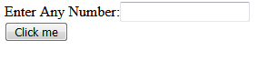

File Name : **JavaScript No is divisible by 5 or not**

Code:

<html>

<body>

Number 1: <input type="text" id="n1" />

<br/>

<input type="button" value="Check" onclick="check ()"/>

<script>

function check()

{

var a = parseInt (document.getElementById("n1").value);

if(a%5==0)

{

alert(a + "number is divisible by 5");

}

else{

alert(a + " number is not divisible by 5");

}

}

</script>

</body>

</html>

OUTPUT:



File Name : **JavaScript greatest no.**

<html>

<head>

<title></title>

</head>

<body style="background: green; color: white;">

<hr>

Number 1<input type="text" id="n1" name="n1"/>

<br>

<br>

Number 2<input type="text" id="n2" name="n2"/>

<br>

<br>

Number 3<input type="text" id="n3" name="n3"/>

<br>

<br>

<input type="button" value="Check Which One Is Greatest" onclick="check()"/>

<hr>

<script>

function check()

{

var a, b, c;

a = parseInt(document.getElementById("n1").value);

b = parseInt(document.getElementById("n2").value);

c = parseInt(document.getElementById("n3").value);

if (a>b&&a>c) {

alert("a is Gratest");

}

else if(b>a&&b>c){

alert("b is Greatest");

}

else {

alert("c is Greatest");

}

}

</script>

</body>

</html>

OUTPUT:

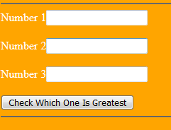

File Name: SOLOLEARN HTML

CERTIFICATE



File Name: SOLOLEARN CSS

CERTIFICATE

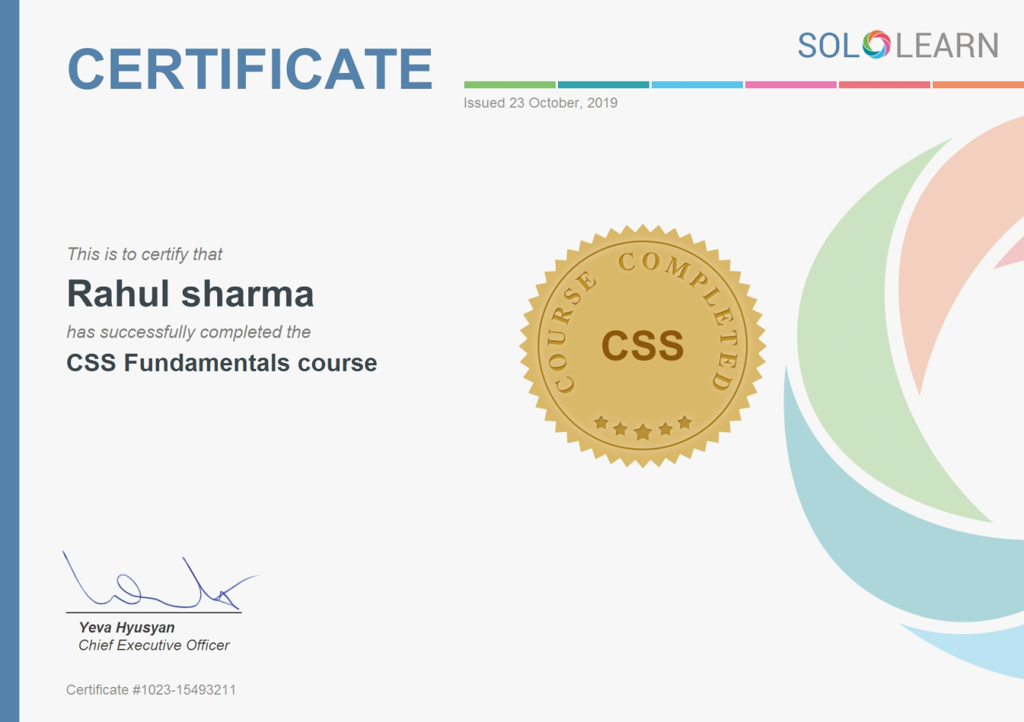

File Name: SOLOLEARN JAVASCRIPT

CERTIFICATE

